**EXP:4 CREATE A WEB PAGE TO ACCEPT USERNAME AND AGE AND**

**DISPLAY IT ON BROWSER**

**AIM:**

Create a web form that accepts a user's name and age. Write a Servlet to process the form data and display it back on the browser.

**CODE:**

**INDEX.HTML**

<!DOCTYPE html>

<html>

<head>

<meta charset="ISO-8859-1">

<title>Web-Page</title>

</head>

<body>

<form action="/mohana/DisplayUser">

<p>

<label for="username">Username:</label>

<input type="text" class="username" name="username" placeholder="Enter your name" required/><br><br>

</p>

<p>

<label for="age">Age:</label>

<input type="number" class="age" name="age" placeholder=" Enter Age">

</p>

<input type="submit" value="Accept">

</form>

</body>

</html>

**DISPLAYUSER.JAVA**

package com.mohana.servlet;

import java.io.IOException;

import java.io.PrintWriter;

import javax.servlet.ServletException;

import javax.servlet.annotation.WebServlet;

import javax.servlet.http.HttpServlet;

import javax.servlet.http.HttpServletRequest;

import javax.servlet.http.HttpServletResponse;

/**

* Servlet implementation class DisplayUser

*/

@WebServlet("/DisplayUser")

public class DisplayUser extends HttpServlet {

private static final long serialVersionUID = 1L;

/**

* @see HttpServlet#HttpServlet()

*/

public DisplayUser() {

super();

// TODO Auto-generated constructor stub

}

/**

* @see HttpServlet#doGet(HttpServletRequest request, HttpServletResponse response)

*/

protected void doGet(HttpServletRequest request, HttpServletResponse response) throws ServletException, IOException {

String a = request.getParameter("username");

int b = Integer.parseInt(request.getParameter("age"));

PrintWriter p=response.getWriter();

if(b<=0){

p.println("Login Failed");

}

else {

p.println(a);

p.println(b);

}

}

/**

* @see HttpServlet#doPost(HttpServletRequest request, HttpServletResponse response)

*/

protected void doPost(HttpServletRequest request, HttpServletResponse response) throws ServletException, IOException {

// TODO Auto-generated method stub

doGet(request, response);

}

}

**OUTPUT**:

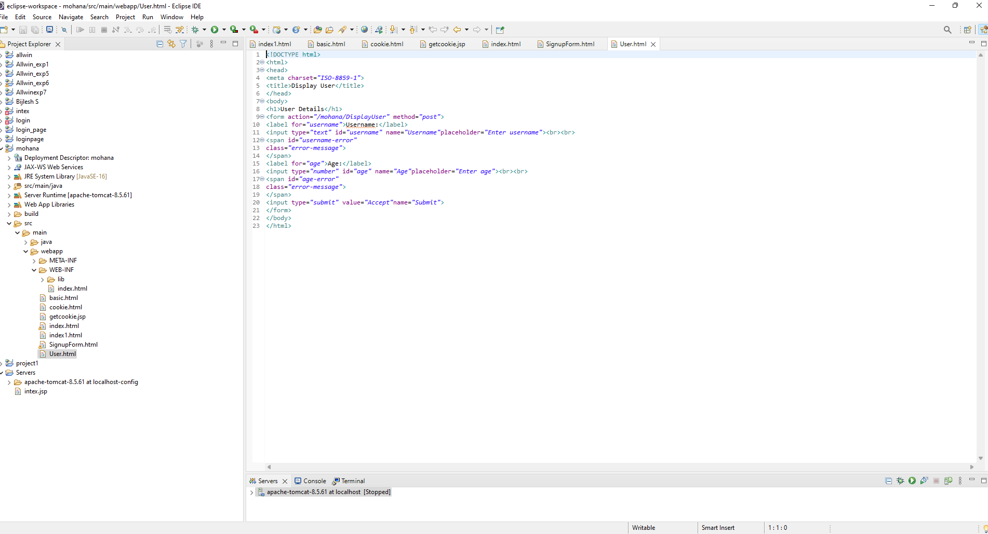

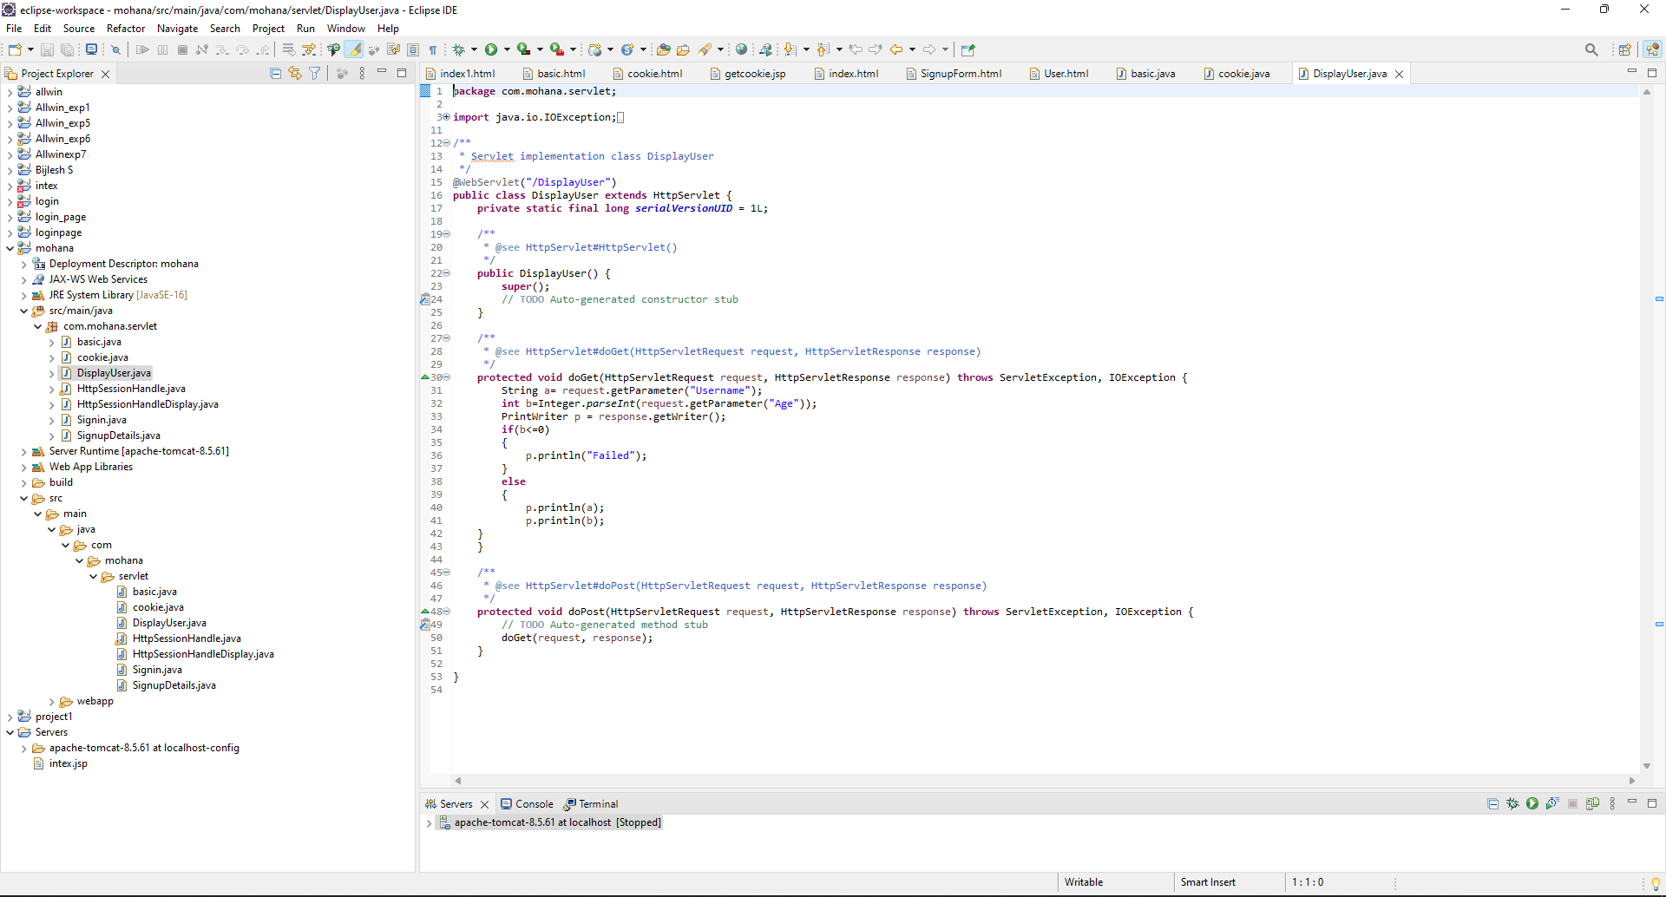

**RESULT:**

Validating the username and age is is done successfully and displayed in the browser.